YEAR 1 HOMEWORK – TERM 1, WEEKS 6 & 7
Please return your homework to school on the Friday 11Th March (2 weeks)
Reading  Read for at least 15 minutes each night. | History  There are many different kinds of families in our community. Complete the ‘Who Is My Family?’ activity to show the class who is in your family. You can draw and label the different members of your family.  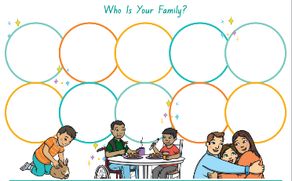 | Writing  Write three interesting sentences each week about your family, your weekend or a book you have read. Remember to edit your sentences and use interesting describing words.  Check the spelling of your words. Use capital letters and full stops.  Remember to use descriptive language.
Maths  Make Ten Again- You will need a deck of playing cards with the picture cards and 10’s removed (ace=1).  - One player deals all cards face up in a 3 x 3 array. There should be four cards in each pile.  - Players take turns to pick up any number of cards, which when added make 10 (e.g., 3, 3 and 4 or 6 and 4). As cards are taken from the pile a new card is revealed underneath.  - Keep playing until all the cards are used or you can’t make any more 10’s.  - The winner is the player with the most cards at the end of the game.  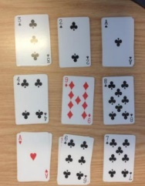 | Religion  Lent: This is the first week of Lent. Talk to your family about what promises they are making for Lent. Are you going to give something up? Or maybe you will make a promise to do something to help others? Record your response in your homework book | PDHPE  Cross country is coming up! Go out for some walks or jogs with your family to start building up your stamina. Don’t forget to stretch first!

