YEAR 1 HOMEWORK – TERM 2, WEEKS 4 & 5
Please return your homework to school on Friday 27th May (2 weeks)
Reading  Read for at least 15 minutes each night and complete your home reading diary. | PDH  Talk to your parents and ask them to tell you three things that make you unique.  You can include a photo of yourself  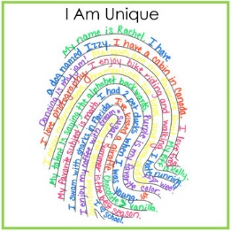 | Spelling  Write three interesting sentences  each week about your family, your  weekend or a book you have read.  Remember to edit your sentences  and use interesting describing  words.  Check the spelling of your words. Use capital letters and full stops.  Remember to use descriptive language. (adjectives)
Maths  Answer the following word problem on a new page in your homework book.  My friend says that these two numbers are the same.  24 42  Do you agree? Represent your answer in as many ways as you can.  Practise counting forwards and backwards by 2s, 5s and 10s to 100+ | Religion  We have all been asked to be Caretakers of God’s Garden: What have you done this week to care for God’s Garden? Write and/or draw ways you have been a good caretaker. | English  Watch the clip- All About Koalas for Kids: Koalas for Children - FreeSchool  https://www.youtube.com/watch?v=PzU-DjUMzsg  Record 3 interesting facts you learnt about koalas in your homework, you might like to draw a diagram of a koala.

