YEAR 1 HOMEWORK – TERM 1, WEEKS 3 & 4
Please return your homework to school on Friday 25Th February (2 weeks)
Reading  Read for at least 15 minutes each night. | Science  Investigate how you can make toys or objects at home move using push and pull forces. Draw a picture of the object and use force arrows to show the direction it is moving.  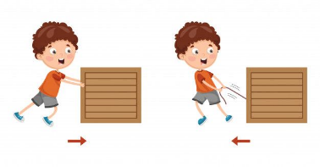 | Spelling  Write three interesting sentences each week about your family, your weekend or a book you have read. Remember to edit your sentences and use interesting describing words.  Check the spelling of your words. Use capital letters and full stops.  Remember to use descriptive language.
Maths  Number Busting:  Choose a number between 10 and 30. How can you represent it using materials from your maths and Me kit and your home?  - Draw it  - Bundles  - Write the number in words  - Tally  - Counters  - Measuring tape  - 1 more, 1 less, 10 more, 10 less  - Odd or even?  Take a picture of your work or draw it in your homework book. | Religion  Baptism:  Create a presentation (poster or PowerPoint) about your Baptism. You may want to include information about where you were baptised, who are your Godparents, photos, when you were Baptised and what you wore.  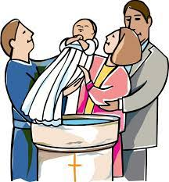 | PDH  Talk to your mum and dad about your family’s cultural background and complete the “My Cultural Background’ Activity sheet

My Cultural Background! Name:
My family came from… | The language they speak there is… | This is the flag….
Some traditional food they eat there is… | This is our traditional clothing… | Here is an interesting fact…

